**CENTRE FOR DEVELOPMENT OF ADVANCED COMPUTING**

** Advanced Computing Training School (ACTS)**

**ATC NETCOM JAIPUR**

**Core Java Scholarship Lab SET**

**Student ID: ______ Student Name: _____________________________ Father’s Name ________________________________**

**Attempt Question Compulsory**

### write java program to implement Inheritance with following example:

Person will have name and age as data members. Teacher and employee will inherit data members in the super class and create its own method myProfession() to display their profession. Then create objects of Teacher, Permanent, and Contract employee to display their profession..

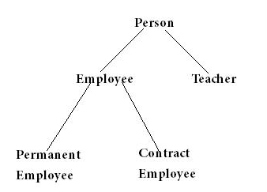

1. Create an abstract class Figure having variables dim1,dim2 of double type and an abstract method area, then make two subclasses Rectangle and Triangle which will implement the area method. Create the abstract class reference variable, assign subclass objects to it and print the corresponding area.
2. Implement a class Employee. An employee has a name and salary.Write a default constructor. Write a constructor with parameters(name and salary). Write a member method printEmpDetails() which prints name and salary. Implement another class EmployeeDemo which contains the main() and does the following: Creates Employee object e with the following details ○ Name : Harry Smith ○ Salary : 10000 Prints employee “e1” details and employee “e2” details using printEmpDetails() constructed using the no parameter constructor and the parameterized constructor respectively

**Students Sign Invigilator Sign Date**